Test Case: tc006_SPX_Dev5_Crear_Requisicion_Spot_Tipo_Cobro_Proyect_Urgent
Step 1 - Enter username and password and click to button Enter: Credentials Entered
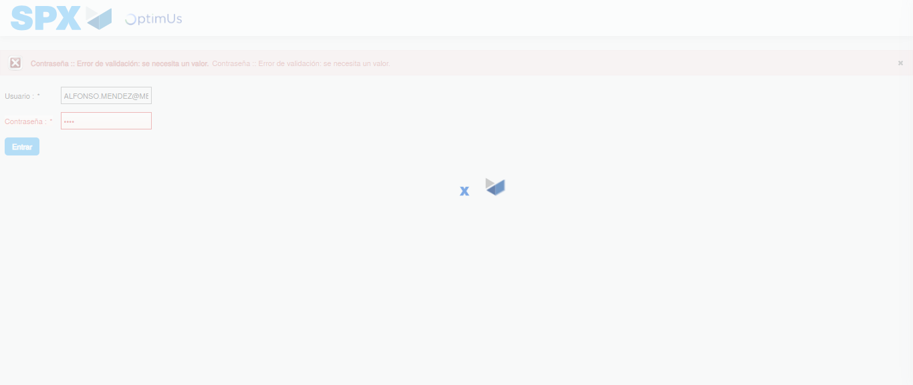Image file-name: QC_Testing-tc006_SPX_Dev5_Crear_Requisicion_Spot_Tipo_Cobro_Proyect_Urgent-1783376977575

Step 2 - Select to UEN and Access to Spot Buy Requisitions : UEN Correctly selected and Correct access
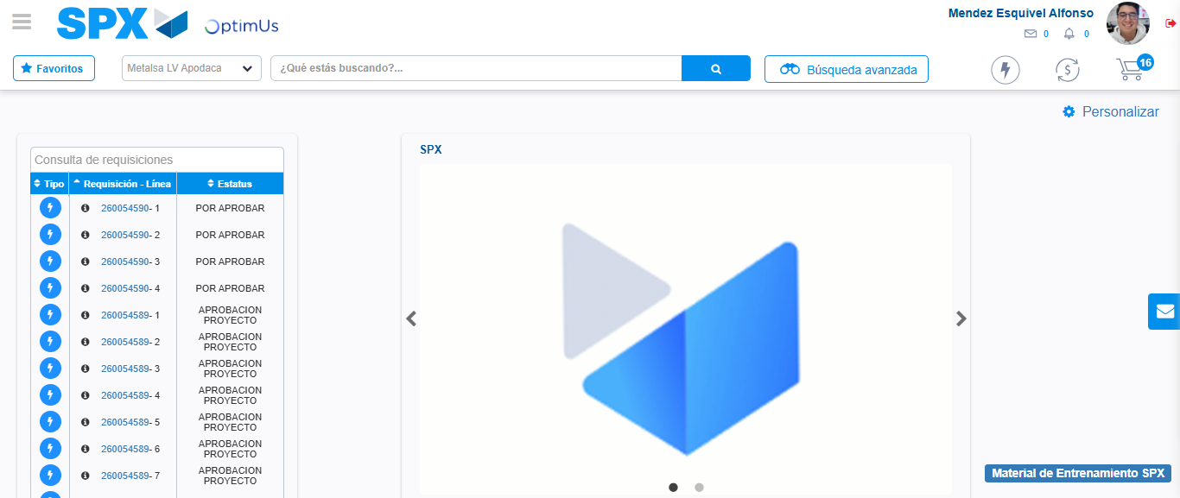Image file-name: QC_Testing-tc006_SPX_Dev5_Crear_Requisicion_Spot_Tipo_Cobro_Proyect_Urgent-1783377003022

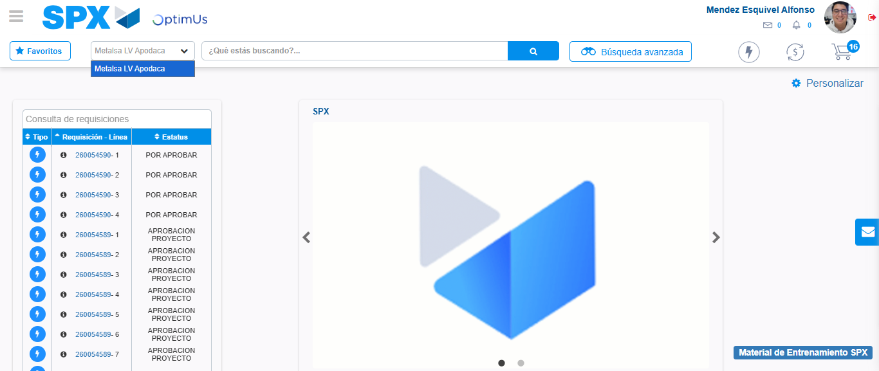Image file-name: QC_Testing-tc006_SPX_Dev5_Crear_Requisicion_Spot_Tipo_Cobro_Proyect_Urgent-1783377005488

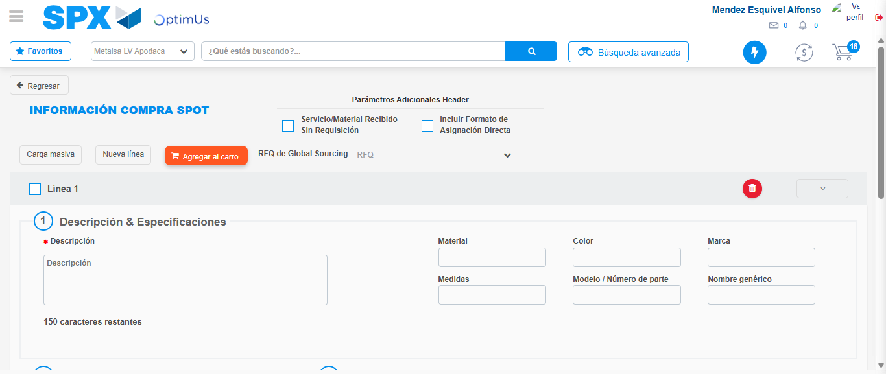Image file-name: QC_Testing-tc006_SPX_Dev5_Crear_Requisicion_Spot_Tipo_Cobro_Proyect_Urgent-1783377026003

Step 3 - Data Capture Spot Buy Requisition: Data captured correctly
Image file-name: QC_Testing-tc006_SPX_Dev5_Crear_Requisicion_Spot_Tipo_Cobro_Proyect_Urgent-1783377026237

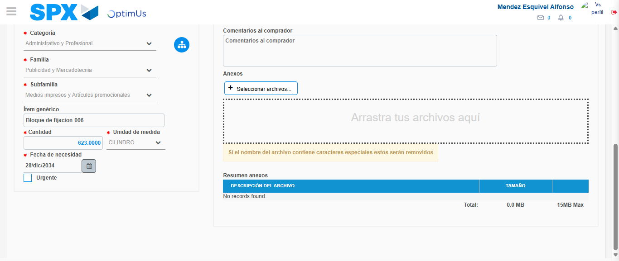Image file-name: QC_Testing-tc006_SPX_Dev5_Crear_Requisicion_Spot_Tipo_Cobro_Proyect_Urgent-1783377036124

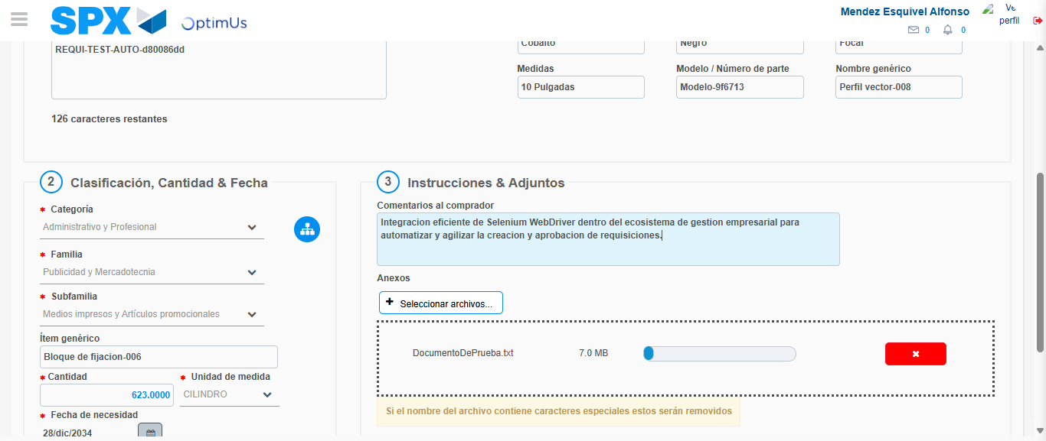Image file-name: QC_Testing-tc006_SPX_Dev5_Crear_Requisicion_Spot_Tipo_Cobro_Proyect_Urgent-1783377036868

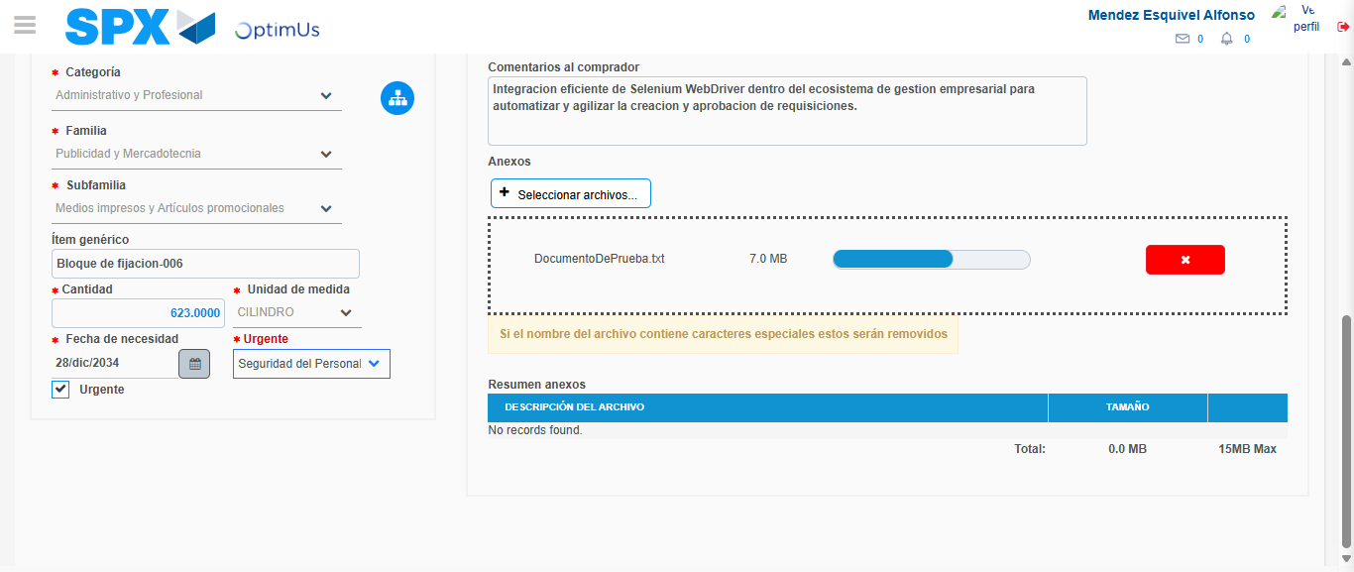Image file-name: QC_Testing-tc006_SPX_Dev5_Crear_Requisicion_Spot_Tipo_Cobro_Proyect_Urgent-1783377040441

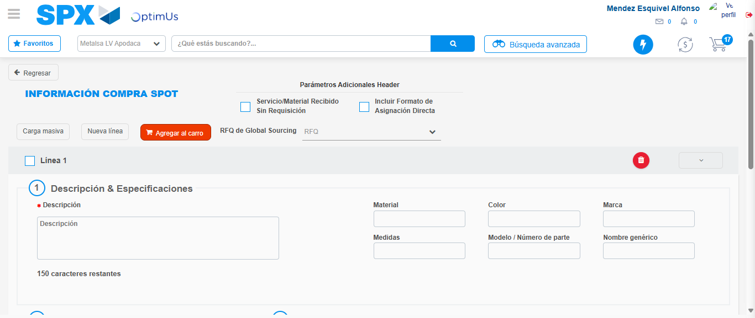Image file-name: QC_Testing-tc006_SPX_Dev5_Crear_Requisicion_Spot_Tipo_Cobro_Proyect_Urgent-1783377048548

Step 7 - Return to Main Page SPX : Return to Main Page SPX
Image file-name: QC_Testing-tc006_SPX_Dev5_Crear_Requisicion_Spot_Tipo_Cobro_Proyect_Urgent-1783377003022

Image file-name: QC_Testing-tc006_SPX_Dev5_Crear_Requisicion_Spot_Tipo_Cobro_Proyect_Urgent-1783377005488

Image file-name: QC_Testing-tc006_SPX_Dev5_Crear_Requisicion_Spot_Tipo_Cobro_Proyect_Urgent-1783377026003

Image file-name: QC_Testing-tc006_SPX_Dev5_Crear_Requisicion_Spot_Tipo_Cobro_Proyect_Urgent-1783377050796

Image file-name: QC_Testing-tc006_SPX_Dev5_Crear_Requisicion_Spot_Tipo_Cobro_Proyect_Urgent-1783377050965

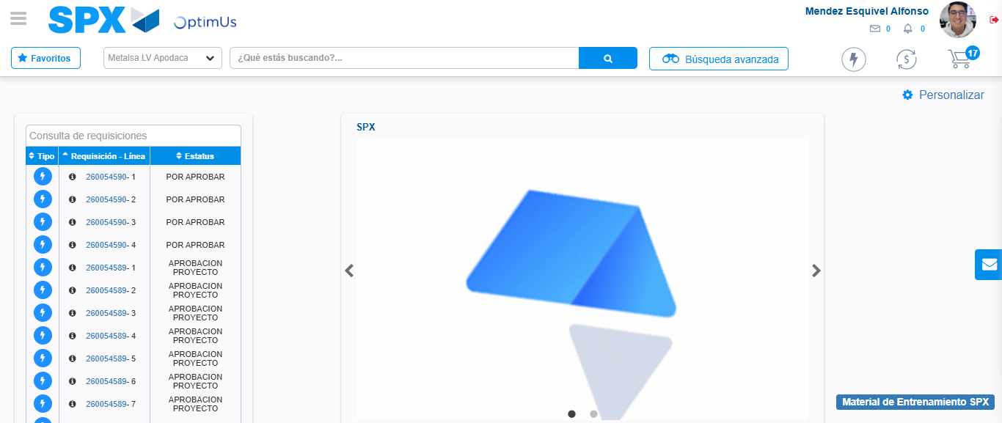Image file-name: QC_Testing-tc006_SPX_Dev5_Crear_Requisicion_Spot_Tipo_Cobro_Proyect_Urgent-1783377072119

Step 8 - Log Out : Log Out SPX
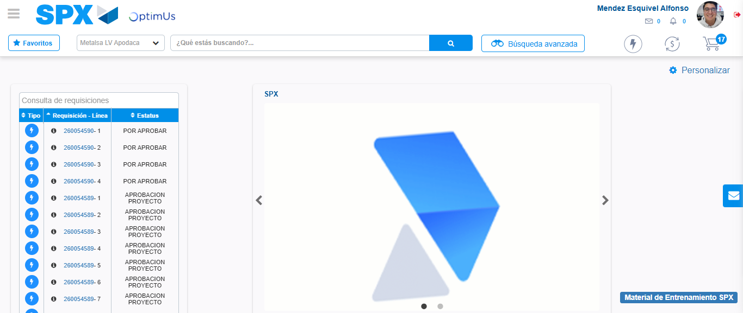Image file-name: QC_Testing-tc006_SPX_Dev5_Crear_Requisicion_Spot_Tipo_Cobro_Proyect_Urgent-1783377072346

